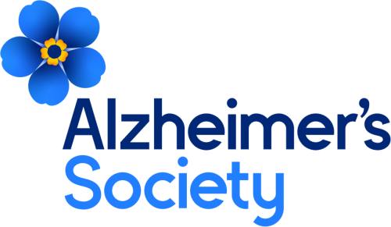

YEO VALLEY LIONS CLUB CHARITY GOLF DAY ENTRY FORM
IN AID OF THE LOCAL ALZHEIMER’S SOCIETY GROUP

Alzheimer’s Society vow to help end the devastation caused by dementia, through dedicated support and research into life-changing treatments.

TALL PINES GOLF CLUB - Thursday 2ND May 2024
ENTER IN TEAMS OF FOUR
TEAM NAME……………………………………Max h/cap allowance 24 men/36 Ladies
PLAYER A………..………………………………………………. HANDICAP……......
PLAYER B…………………………………………………………. HANDICAP………...
PLAYER C…………………………………………………………. HANDICAP…………
PLAYER D……...…………………………………………………. HANDICAP…………
TEAM CAPTAIN’S CONTACT DETAILS
NAME …………………………..…………………………………………………………….
ADDRESS…..……………………………………………………………………………………………………………………………………………………………………………………
PHONE NO: ………………………………… MOBILE NO:……..…………………………
E-MAIL …………..………………………………………………………………………......
PREFERRED TEE TIME………….……… (first come, first served between 9.00 till 14.00)

ENTRY FEE £220 PER TEAM OF 4 - fee includes 2 course buffet and prizes
I would like to sponsor a Tee ………. and enclose an additional £120 cheque
I would like to donate a raffle prize (description)………………………………………………….

Please make cheques payable to: YEO VALLEY LIONS CLUB and return to:
YEO VALLEY LIONS, C/O DEREK WHITE - 84 CLAVERHAM ROAD, YATTON, BRISTOL, BS49 4LD.
Or
BACS to Lloyds TSB Account Name - Yeo Valley Lions Club – Activities
Sort Code: 30-99-51 A/C 02219175
All personal data/special category data herein are processed in accordance with UK data protection legislation. All feasible security measures are in place. If you are not the intended recipient please notify the sender and delete all copies. Thank you

